GaiaEx Privacy Policy

1. Introduction

GaiaEx ("we," "our," or "us") is committed to protecting the privacy and security of your personal data. This Privacy Policy explains how we collect, use, disclose, and protect your personal information when you access or use our platform, including our website, mobile applications, and other related services (collectively, the "Platform"). By using the Platform, you agree to the terms of this Privacy Policy. If you do not agree with these terms, please do not use the Platform.

2. Data Collection

We collect personal data that you provide directly to us when you register for an account, use our services, or communicate with us. We also collect certain information automatically when you interact with the Platform.

2.1 Types of Data Collected

Personal Identification Information: Name, email address, phone number, date of birth, residential address, government-issued ID numbers, and other registration data.

Financial Information: Bank account details, payment information, cryptocurrency wallet addresses, and transaction history.

Technical Data: IP address, browser type and version, device information, operating system, and other technical identifiers.

Behavioral Data: Usage patterns, preferences, and interactions with the Platform.

2.2 Sources of Data

Direct Collection: We collect personal data that you provide directly to us when you register for an account, complete identity verification procedures, initiate transactions, or communicate with our customer support team.

Automatic Collection: We automatically collect certain information through cookies, web beacons, and other tracking technologies when you use the Platform.

Third-Party Sources: We may receive personal data from third-party service providers, such as identity verification services, payment processors, and analytics providers.

3. Use of Data

We use personal data for:

Providing Services: Facilitating transactions, managing accounts, processing payments.

Improving Services: Enhancing the Platform based on user interactions.

Security: Monitoring for suspicious activities, preventing fraud, and complying with AML/CTF regulations.

Communication: Sending important updates and marketing materials.

4. Data Sharing

We may share your personal data with third-party service providers for identity verification, payment processing, analytics, and other necessary functions.

5. Data Security

We implement encryption, firewalls, and access controls to protect personal data. Users are responsible for maintaining the security of their account credentials.

6. Data Retention & Account Deletion

6.1 Retention Period

We retain your personal data for as long as necessary to fulfill its intended purposes, comply with legal obligations, and resolve disputes. For example, transaction records and identity verification data are kept for at least five years to meet AML/CTF regulations.

6.2 Account Deletion

Users can request account deletion through the GaiaEx mobile application.

Steps to Delete Your Account:

- Open the GaiaEx App and go to Profile (top-left corner).
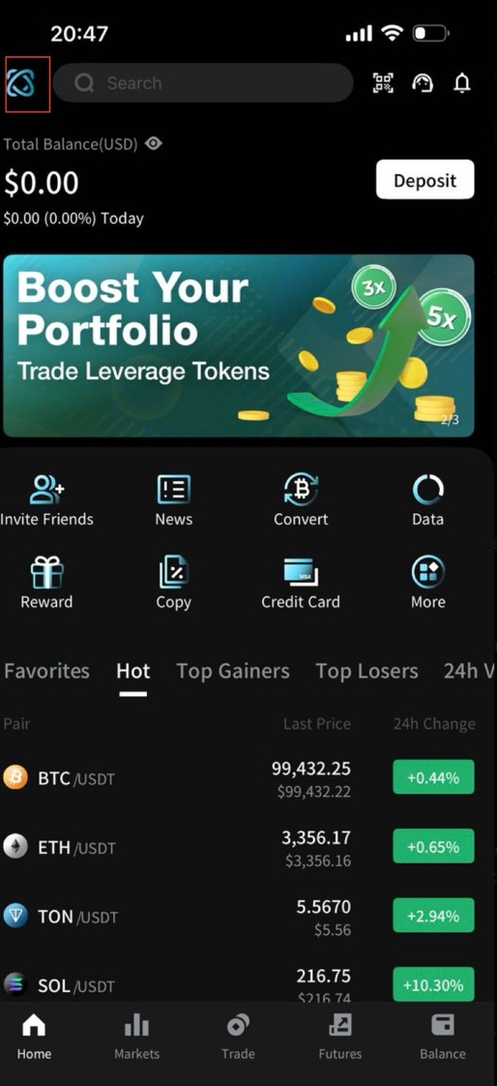

- Navigate to Security Settings.
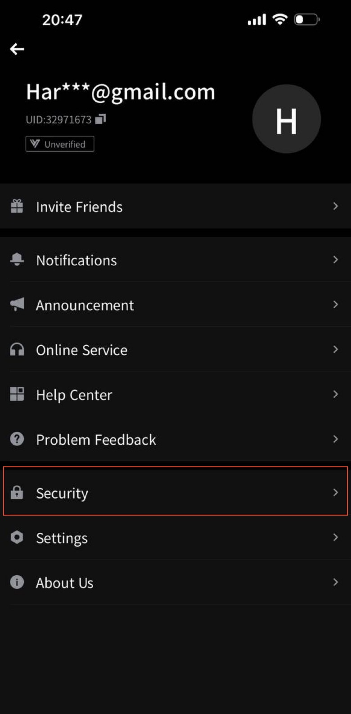

- Click on Delete Account.
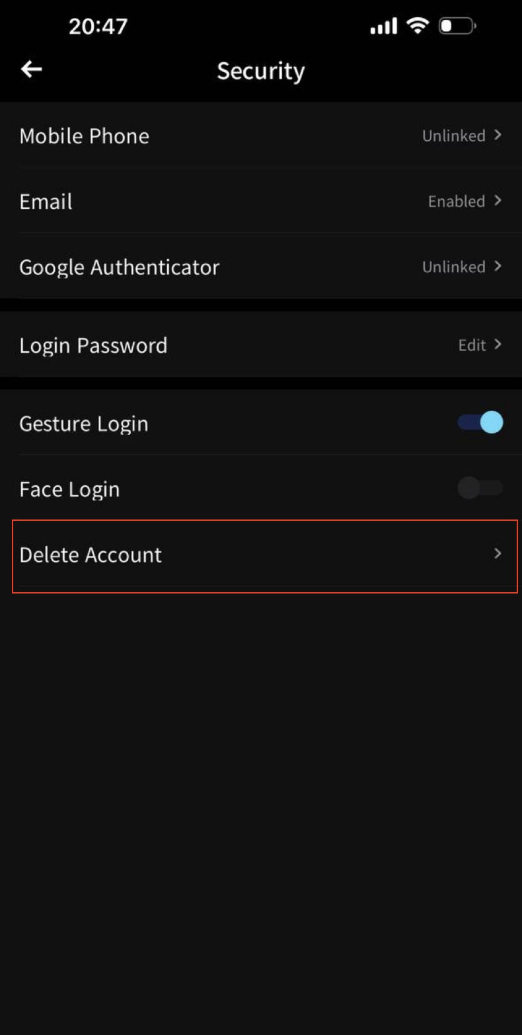

- Review and acknowledge the risk warnings.
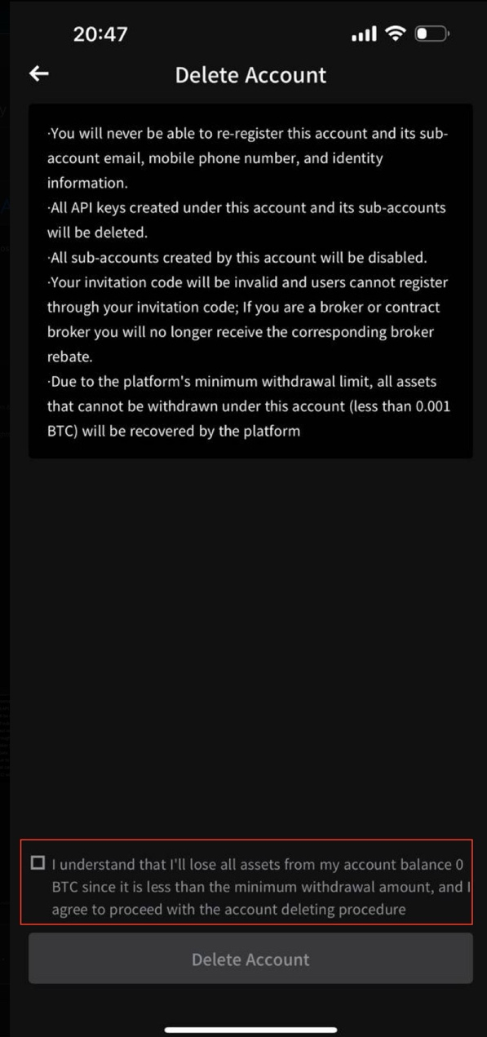

- Confirm deletion.
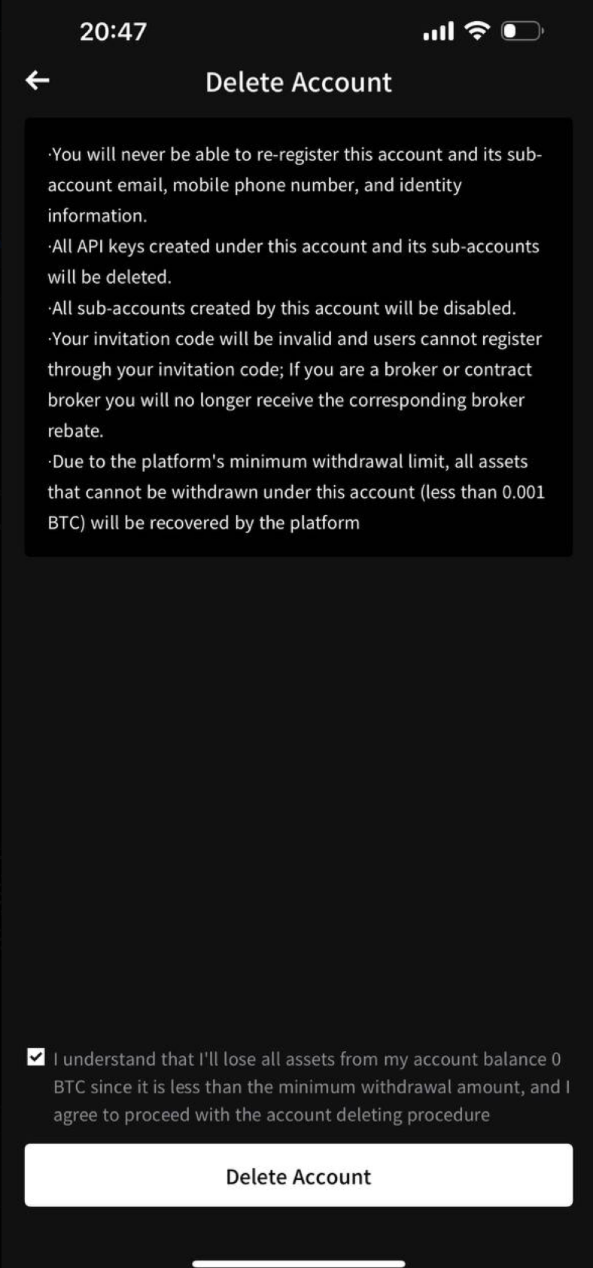

Important Notes on Account Deletion:

Users must clear all assets, orders, and positions before account deletion can proceed.

Once deleted, the account cannot be restored or reused.

While the account is deleted, certain transaction data may be retained for regulatory compliance.

Alternatively, users may request account deletion via email at support@gaiaex.com. If the deletion requires additional verification, GaiaEx will provide further instructions.

7. User Rights

Users have the right to access, correct, delete, or transfer their data, as well as withdraw consent for data processing.

8. Cookies and Tracking Technologies

We use cookies to enhance user experience. Users can manage or disable cookies through browser settings.

9. International Data Transfers

Data may be transferred to jurisdictions outside a user’s home country. We ensure compliance with applicable data protection laws.

10. Children's Privacy

GaiaEx is not intended for users under 18. If we become aware of children’s data being collected, it will be deleted promptly.

11. Changes to the Privacy Policy

We may update this policy periodically. Continued use of the Platform after updates constitutes acceptance of the revised policy.

12. Contact Information

For questions about this Privacy Policy or data deletion requests, contact us at support@gaiaex.com.

